SFM actuator issue

Purpose
This document records the mechanical issues observed on the SFM actuator during extended run testing, the conditions under which they reproduce, and the proposed mechanical fix.

Test Setup
Nodes were run continuously for approximately 16 hours, executing a dispense cycle every 10 minutes (roughly 96 cycles per node). The issues below were observed visually and were reproducible across repeat cycles; the attached GIFs show the failure in motion and the still images show the areas where added tolerance may resolve it.

Findings

Finding 1 — Plate-to-bin clearance
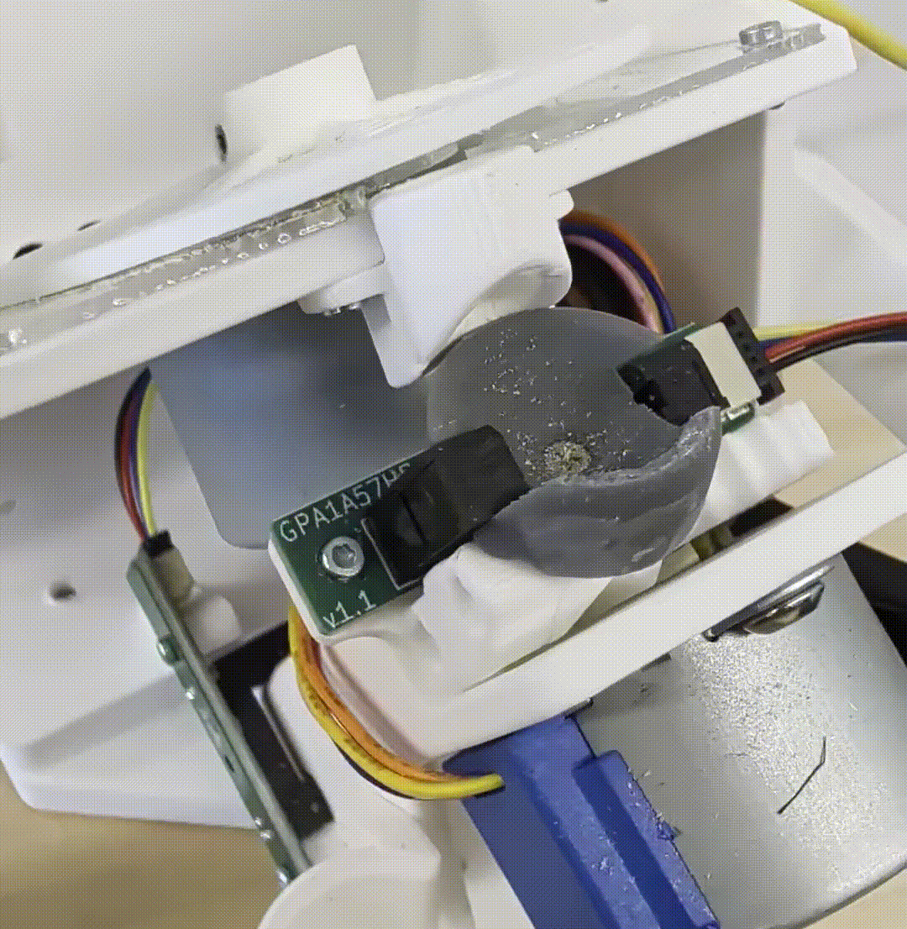
There is not enough tolerance between the plate and the bin. The behavior is intermittent: on some cycles the plate passes through cleanly, and on others it binds and stalls in the bin opening. See the GIF below for the motion at the point of failure.

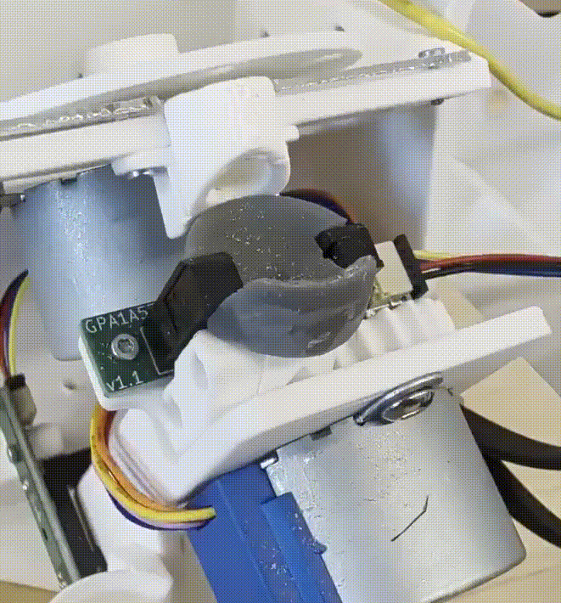
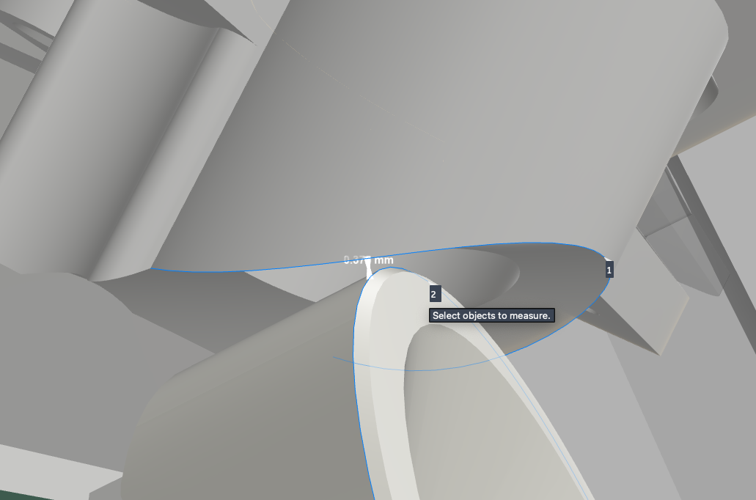

Finding 2 — Actuator contacts the edge on travel
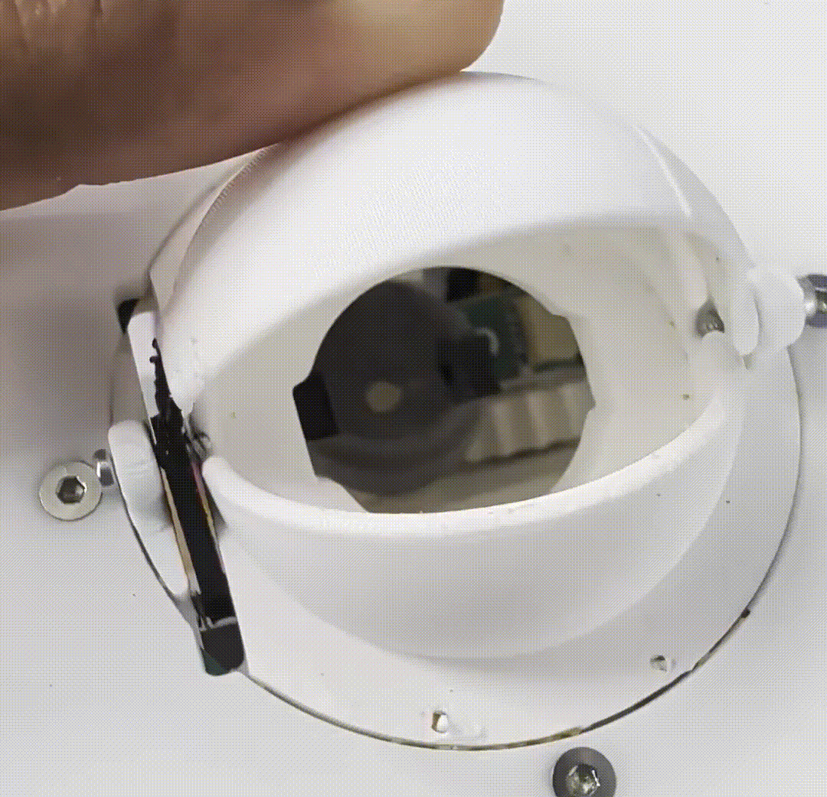
On some cycles the actuator contacts the edge during travel. The still image shows the contact point — increasing the tolerance at that edge should clear the interference.
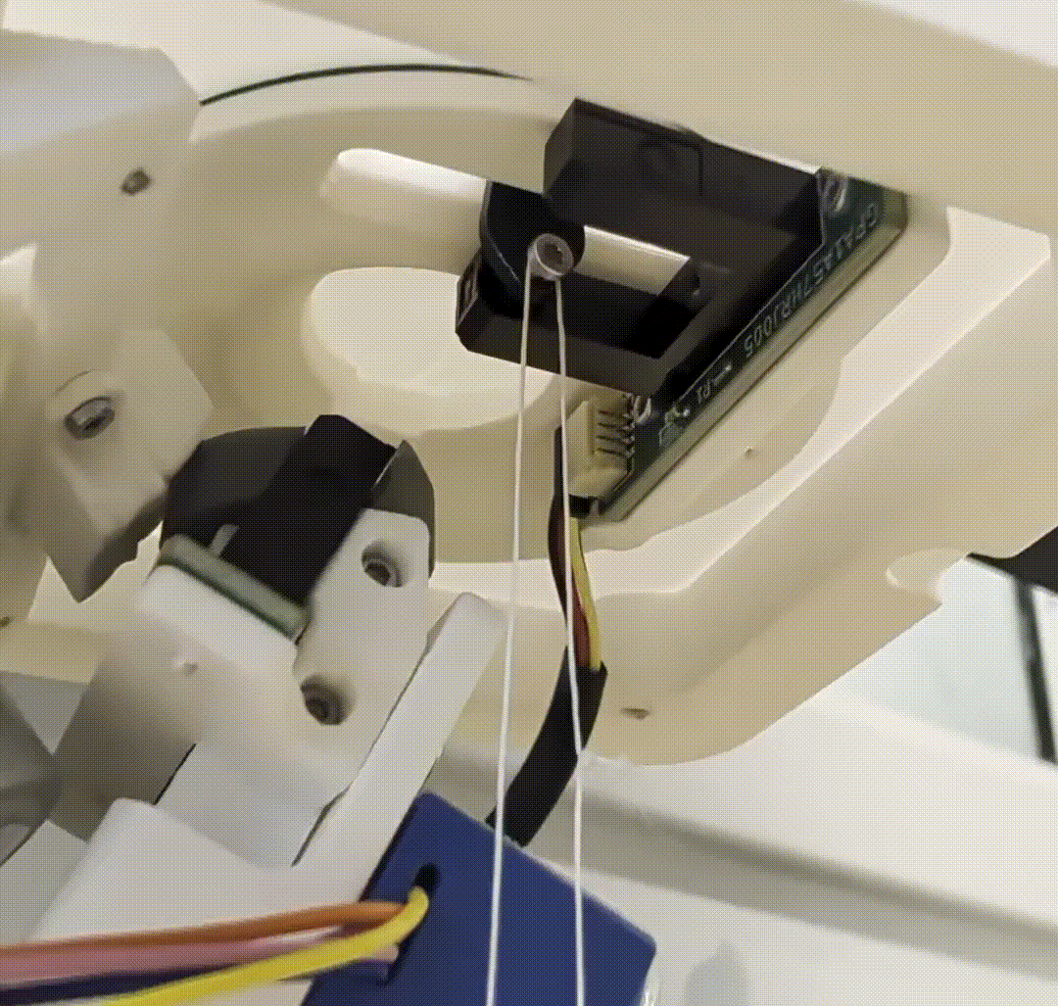


The clearance at this interface is insufficient. The design tolerance is 1.1 mm but play in the actuator arm allows the assembly to wiggle within that gap, and the resulting deflection grows as the actuator travels upward. By the top of the stroke the effective clearance is smaller than the 1.1 mm designed in, which is where the interference occurs.

Root Cause
Nothing observed indicates a control or firmware fault. The actuator completes its commanded motion in every case; the failures are purely mechanical.

Proposed Solution
Increase the mechanical tolerance at each of identified areas.
- Open up the plate-to-bin clearance so the plate passes through with margin on both sides, eliminating the intermittent bind (Finding 1).
- Increase the tolerance at the third interface in the direction shown in the attached images (Finding 2).

